**Guided Capstone Project Report**

**Background**

Big Mountain Resort is a ski resort located in Montana that offers spectacular views of Glacier National Park and Flathead National Forest, with access to 105 trails and many features. Every year about 350,000 people ski or snowboard at Big Mountain. This mountain can accommodate skiers and riders of all levels and abilities. Big Mountain Resort has recently installed an additional chair lift to help increase the distribution of visitors across the mountain. The additional chair increases their operating costs by $1,540,000 this season. The company would like to have a better data-driven business strategy on how to select a better value for their ticket price relative to its position in the market.

**Problem Statement Hypothesis**

How can Big Mountain Ski Resort capitalize its facilities and cut cost meanwhile increasing the value of ticket prices relative to its position in the market to cover operating cost of new chair lift this season?

**Methodology/ Modelling**

To develop a pricing model the Data science method was used to compare the other resorts in the same market segment against Big Mountain.

Big Mountain Resort has been reviewing potential scenarios:

1. Permanently closing down up to 10 of the least used runs. This doesn't impact any other resort statistics.

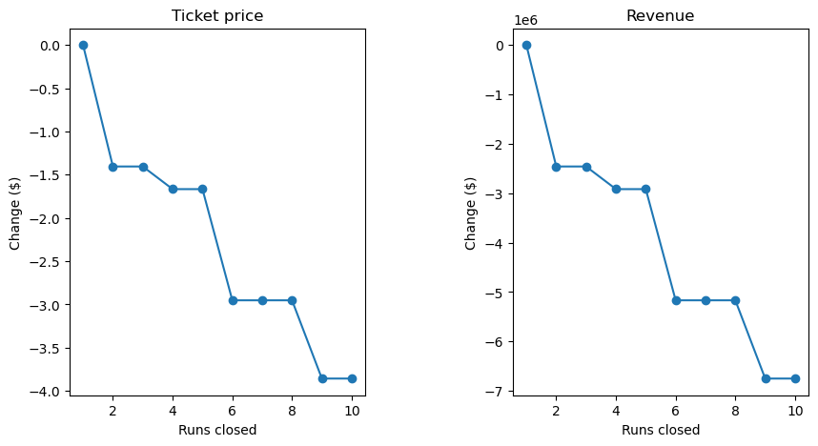

* The model says closing one run makes no difference. Closing 2 and 3 successively reduces support for ticket price and so revenue.

1. Increase the vertical drop by adding a run to a point 150 feet lower down but requiring the installation of an additional chair lift to bring skiers back up, without additional snow making coverage.

* This scenario increases support for ticket price by $1.00 over the season, which could be expected to amount to $1750000

1. Same as number 2, but adding 2 acres of snow making cover.

* Made no difference to by adding snow to the acreage.

1. Increase the longest run by 0.2 mile to boast 3.5 miles length, requiring an additional snow making coverage of 4 acres.

* Also made no difference.

**Recommendations/ Future Model**

Increase the vertical drop by adding a run to a point 150 feet lower down but requiring the installation of an additional chair lift to bring skiers back up, without additional snow making coverage provided the best results to support for ticket price by $1.00 over the season, which could be expected to amount to $1750000.

It is recommended that the pricing and marketing teamwork alongside each other to continue testing the parameters utilized and determine other factors to consider other than the operation cost of adding a new chair.